QUESTION 9:

E-BOOK MANAGEMENT SYSTEM:

ACTIVITY DIAGRAM:

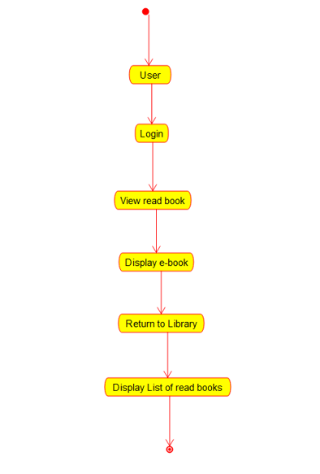

COMPONENT DIAGRAM:

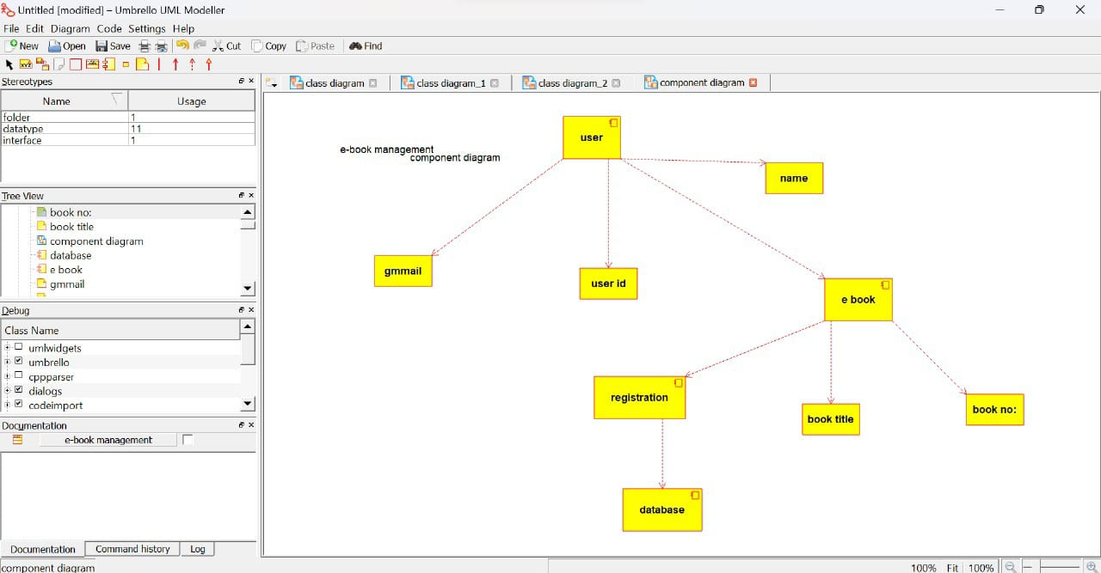

USE CASE DIAGRAM:

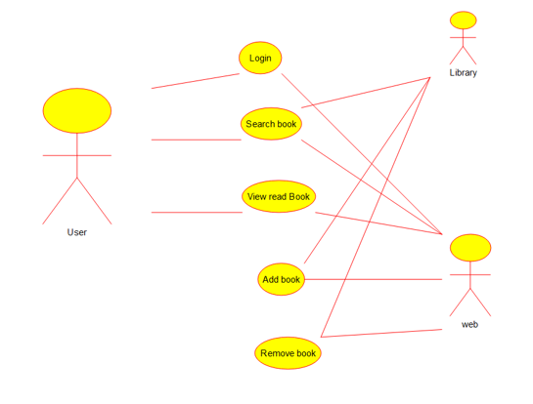

CLASS DIAGRAM:

